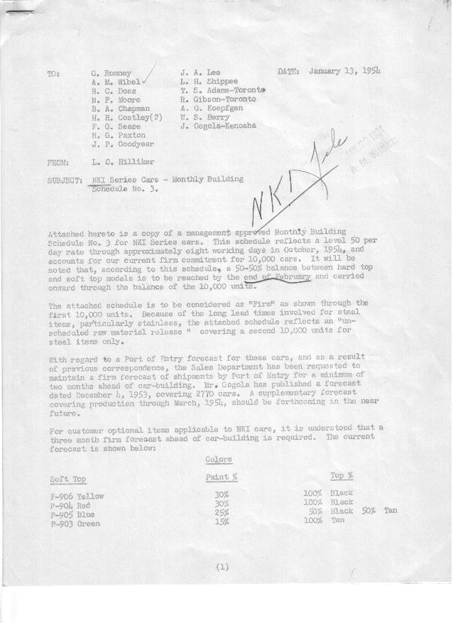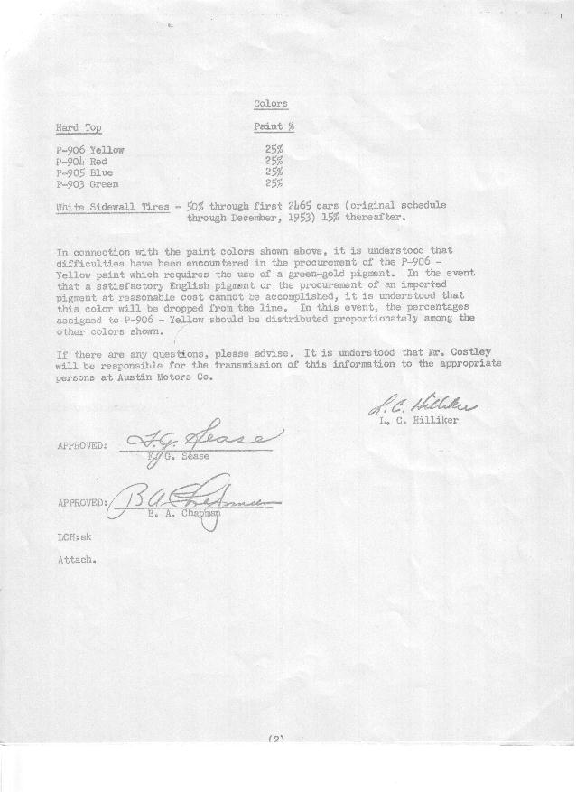

FORM PLAN 68 REV. 9-40-N.K.P PRINTED IN U.S.A

SCHEDULE NO. ______3_________ DATE January 11, 1953 (1954?) MONTHLY BUILDING SCHEDULE APPROVED_____F. G. Sease (signed) ________DATE__1-15-54 ___ REVISION NO. ________________ DATE ________________ PRODUCT APPROVED_____B. A. Chapman (signed) ___________DATE__1-18-54____ ___
NKI Series Cars – Austin Motors Co., Ltd., - England

DESCRIPTION | BUILT  ◻ACT EST  THRU  12-31-53 | FIRM BUILDING SCHEDULE  (FABRICATED MATERIAL RELEASE) |  |  |  |  |  |  |  |  |  |  |  |  |  |  |  |  |  | GRAND  TOTAL
DESCRIPTION | BUILT  ◻ACT EST  THRU  12-31-53 | MONTH January, 1954  DAYS 21 |  |  | MONTH February  DAYS 20 |  |  | MONTH March  DAYS 23 |  |  | MONTH April  DAYS 19 |  |  | MONTH May  DAYS 21 |  |  | Unscheduled Raw  Material Release |  |  | GRAND  TOTAL
DESCRIPTION | BUILT  ◻ACT EST  THRU  12-31-53 | DAILY | MONTH | CUM’L  TOTAL | DAILY | MONTH | CUM’L  TOTAL | DAILY | MONTH | CUM’L  TOTAL | DAILY | MONTH | CUM’L  TOTAL | DAILY | MONTH | CUM’L  TOTAL | For Steel Items Only |  |  | GRAND  TOTAL
NKI Series
Hard-Top Convertible | 687 | 20 | 425 | 1112 | 15 | 300 | 1412 | 25 | 575 | 1987 | 25 | 475 | 2462 | 25 | 525 | 2987
Soft-Top Convertible | 83 | 30 | 625 | 708 | 35 | 700 | 1408 | 25 | 579 | 1987 | 25 | 475 | 2462 | 25 | 525 | 2987
Total | 770 | 50 | 1050 | 1820 | 50 | 1000 | 2820 | 50 | 1154 | 3974 | 50 | 950 | 4924 | 50 | 1050 | 5974
Over/(Under) Sched. 1, Rev. 2 | (1695) |  | (40) | (1735) |  | (40) | (1775) |  | (374) | (2149) |  | (427) | (2576) |  | 1050 | (1526)
 |  | MONTH June  DAYS 19 |  |  | MONTH July  DAYS 17 |  |  | MONTH August  DAYS 16 |  |  | MONTH September  DAYS 22 |  |  | MONTH October  DAYS 7
Hard-Top Convertible |  | 25 | 475 | 3462 | 25 | 425 | 3887 | 25 | 400 | 4287 | 25 | 550 | 4837 | 25 | 163 | 5,000 |  | 5,000 |  | 10,000
Soft-Top Convertible |  | 25 | 475 | 3462 | 25 | 425 | 3887 | 25 | 400 | 4287 | 25 | 550 | 4837 | 25 | 163 | 5,000 |  | 5,000 |  | 10,000
Total |  | 50 | 950 | 6924 | 50 | 850 | 7774 | 50 | 800 | 8574 | 50 | 1100 | 9674 | 50 | 326 | 10,000 |  | 10,000 |  | 20,000
Over/(Under) Sched. 1, Rev. 2 |  |  | 950 | (576) |  | 850 | 274* |  | 800 | 1074* |  | 1100 | 2174* |  | 326 | 2500* |  | 0 |  | 0
* Schedule No. 1, Rev. 2 had 7500 jobs through April with 2500 jobs
beyond as “Unscheduled Firm Commitment”

